Aim:

The Aim of this program is to access and print an element from a vector from a vector using programming.

Algorithm:

* Define a vector that holds multiple values.
* Specify the position of the element you want to access.
* Use square brackets [ ] to access the element at specified position.
* Display the element that you accessed.

Program:

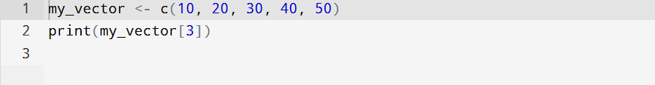

Output:

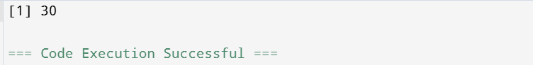

Result:

Writing a program to access and printing an element from a vector using R programming is successfully done.